Report: Sentiment Analysis and Text Classification of IMDB Movie Reviews

Project: NLP Case Study: Sentiment Analysis & Text Classification

Introduction
This project focuses on building a robust sentiment analysis model to classify IMDB movie reviews as either positive or negative. The primary objective is to develop a text classification system that is capable of accurately discerning the sentiment expressed in user-generated movie reviews. These reviews are important in that, they can have applications in customer feedback analysis, product recommendation, and market research. The process involved comprehensive text preprocessing, various vectorization techniques, and the training and evaluation of a Multinomial Naive Bayes classifier. This final report details the methodology, findings, and insights gathered throughout the project, trying as best to cover foundational concepts all the way to the practical implementation and detailed analysis.

Data Description and Preprocessing

Dataset overview
The IMDB movie review dataset (`IMDB Dataset.csv`) was acquired from the Kaggle datasets using the following link; https://www.kaggle.com/lakshmi25npathi/imdb-dataset-of-50k-movie-reviews.
The dataset comprises 50,000 movie reviews, each labeled as either 'positive' or 'negative'. After analysis the dataset was found to be perfectly balanced, with 25,000 positive and 25,000 negative reviews, and contained no missing values. When review length analysis was done, it showed similar average lengths for both positive and negative reviews (around 1294-1324 characters and 229-232 words), indicating a diverse range of content. Performing visualizations such as box plots and histograms further confirmed consistent length distributions across sentiments.

Text Preprocessing Pipeline
A comprehensive text preprocessing pipeline was developed and refined across several stages:
- HTML Tag Removal: The `BeautifulSoup` library was used to remove HTML tags, addressing a common artifact in web-scraped data.
- Lowercasing: All text was converted to lowercase to ensure uniformity.
- Punctuation/Special Character removal: Regular expressions were used to remove non-alphabetic characters, retaining only letters and spaces.
- Tokenization: Text was broken down into individual words (tokens) using NLTK's `word_tokenize`.
- Stopword Removal: Common English stopwords were removed using NLTK's `stopwords` corpus, along with custom domain-specific stopwords to enhance the signal from meaningful words.
- Lemmatization: Words were reduced to their base or dictionary form using NLTK's `WordNetLemmatizer`.
- Sentiment Mapping: Sentiment labels were converted from 'positive'/'negative' strings to numerical values (1 for positive, 0 for negative) for model compatibility.
An in-depth word frequency analysis was conducted post-preprocessing:
- Top General Words: Highly frequent words common to both sentiments (e.g., 'one', 'like', 'would') were identified, along with sentiment-laden words specific to positive ('good', 'great', 'love') or negative ('bad’, ‘waste') reviews.
- Top Adjectives: Analysis focusing solely on adjectives revealed more distinct sentiment indicators, with words like 'good', 'great', 'best' prominent in positive reviews, and 'bad', 'worst', 'poor' dominating negative ones.
- Vocabulary Overlap & Discriminative Words: Visualizations highlighted the shared vocabulary and identified words (e.g., 'wonderful film' for positive, 'this turkey' for negative) that were most discriminative between sentiments.

Data Splitting
The dataset was split into 80% for training (40,000 samples) and 20% for testing (10,000 samples). Stratified sampling was applied to ensure the original class distribution was maintained in both the training and testing sets, critical for unbiased model evaluation.

Methodology

3.1 Feature Extraction: CountVectorizer with N-grams
Textual data was converted into numerical feature vectors using `CountVectorizer`. This technique usually represents documents as a bag of words, counting the occurrences of each word (or n-gram). A crucial aspect was the experimentation with different n-gram ranges (unigrams, bigrams, trigrams, and combinations and so on) to capture local word context. Parameters such as `min_df=5`, `max_df=0.8`, and `max_features=10000` were set to control vocabulary size, filtering out very rare or overly common terms.

3.2 Model Choice: Multinomial Naive Bayes (MNB)
The Multinomial Naive Bayes algorithm was selected for its suitability for text classification tasks, particularly with discrete features like word counts or frequencies. MNB is a probabilistic classifier based on Bayes' theorem, assuming feature independence given the class, making it efficient and effective for large text datasets.

3.3 Hyperparameter Tuning
`GridSearchCV` with 5-fold cross-validation was employed to optimize the `alpha` smoothing parameter for the Multinomial Naive Bayes classifier across various n-gram configurations. This systematic approach aimed to identify the optimal `alpha` value that balanced model complexity and generalization performance, preventing overfitting to the training data.

3.4 Cosine Similarity Analysis
Early in the project, TF-IDF vectorization was used to represent sample reviews (R1-R6) numerically. Cosine similarity, a measure of the cosine of the angle between two non-zero vectors, was then calculated to determine the semantic similarity between these documents. This analysis revealed the "sentiment blindness" of basic vector space models, where reviews with similar topics (e.g., product features) but opposing sentiments could show high similarity (e.g., 0.4727 for R5 vs R6). This highlighted that such models primarily capture topic rather than nuanced sentiment.

3.5 Cosine Similarity Analysis of Top Predictive Features
To further understand the semantic relationships between words most indicative of positive and negative sentiments (derived from the best performing MNB model), a cosine similarity analysis was performed on word co-occurrence vectors. N-grams with the highest (positive) and lowest (negative) log ratios were identified as top predictive features.

Results with Visualizations

4.1 Model Training and Evaluation Results
Experiments systematically compared the performance of Multinomial Naive Bayes models using different n-gram ranges. The results are summarized below:
Ngram  range | vocab_size | best_alpha | cv_f1 | test_accuracy | test_precision | test_recall | testf1 | Time  (s)
(1,1) | 10000 | 0.01 | 0.8386 | 0.8492 | 0.8620 | 0.8271 | 0.8442 | 13.69
(2,2) | 10000 | 0.10 | 0.8570 | 0.8552 | 0.8459 | 0.8644 | 0.8550 | 29.95
(3,3) | 10000 | 0.10 | 0.8265 | 0.8210 | 0.8058 | 0.8401 | 0.8226 | 54.23
(1,2) | 10000 | 0.01 | 0.8529 | 0.8536 | 0.8496 | 0.8551 | 0.8523 | 36.49
(1,3) | 10000 | 0.01 | 0.8522 | 0.8534 | 0.8473 | 0.8579 | 0.8525 | 89.20
(2,3) | 10000 | 0.01 | 0.8492 | 0.8478 | 0.8344 | 0.8632 | 0.8486 | 80.67

The (2, 2) n-gram range (bigrams only) emerged as the best performing configuration, achieving the
highest test F1-Score of 0.8550 and an accuracy of 0.8552 with an optimal `alpha` value of 0.1.
This highlights the effectiveness of bigrams in capturing the local contextual information crucial for
sentiment detection in this dataset.
 | precision | recall | F1-score | support
Negative | 0.8647 | 0.8462 | 0.8554 | 2530
Positive | 0.8459 | 0.8644 | 0.8550 | 2470
Accuracy |  |  | 0.8552 | 5000
Macro avg | 0.8553 | 0.8553 | 0.8552 | 5000
Weighted avg | 0.8554 | 0.8552 | 0.8552 | 5000

The model exhibits strong and balanced performance across both negative and positive classes, indicating its
robustness.

4.2 Baseline Comparison
The MNB model's performance was rigorously compared against two simple baseline classifiers:
- Majority Class Baseline: Achieved an F1-Score of 0.6613 by always predicting the most frequent class.
- Random (Stratified) Baseline: Achieved an F1-Score of 0.4970 by making random predictions stratified by class distribution.
The Multinomial Naive Bayes model demonstrated a significant 29.29% improvement in F1-Score over the majority class baseline, unequivocally validating its superior predictive capability.
Error Analysis: False Positives & False Negatives
A detailed error analysis on the test set revealed that 724 out of 5,000 samples (14.48%) were misclassified. There were 389 False Positives (negative reviews incorrectly classified as positive) and 335 False Negatives (positive reviews incorrectly classified as negative).
Notably, some misclassifications occurred with very high confidence (e.g., 1.0000), suggesting the model struggled with nuanced language such as sarcasm, double negatives, or mixed sentiments.
Reviews classified correctly but with low confidence (around 0.5) indicated inherent ambiguity or mixed signals within the text, posing challenges even for human interpretation.

4.3 Top predictive features
Analysis of the best model's log ratios identified the most discriminative n-grams:
- Top 20 Positive Indicators: E.g., 'wonderful film', 'highly recommended', 'superb and', 'excellent job'.
- Top 20 Negative Indicators: E.g., 'this turkey', 'terrible movie', 'avoid at', 'complete waste'.

4.4 Cosine Similarity of top predictive features
Average Similarity Scores:
- Positive-Positive (within class): 0.0069
- Negative-Negative (within class): 0.0098
- Positive-Negative (between class): 0.0080
Interpretation: The low overall similarity scores and a small class separation score (0.0004) indicated that while individual n-grams are highly predictive, their broader co-occurrence patterns across all documents show some overlap or are not perfectly distinct between positive and negative classes. This suggests that contextual usage of words, even strong sentiment indicators, can be complex.
Most Similar Cross-Class Pairs: Pairs like ('thought that', 'would be') with a similarity of 0.0617 appeared in similar contexts, suggesting that these words describe movie attributes but contribute to opposite sentiments depending on other surrounding words. This highlights the importance of broader context for accurate sentiment detection.

4.5 Visualizations
DMT and Cosine Similarity Matrix heatmaps
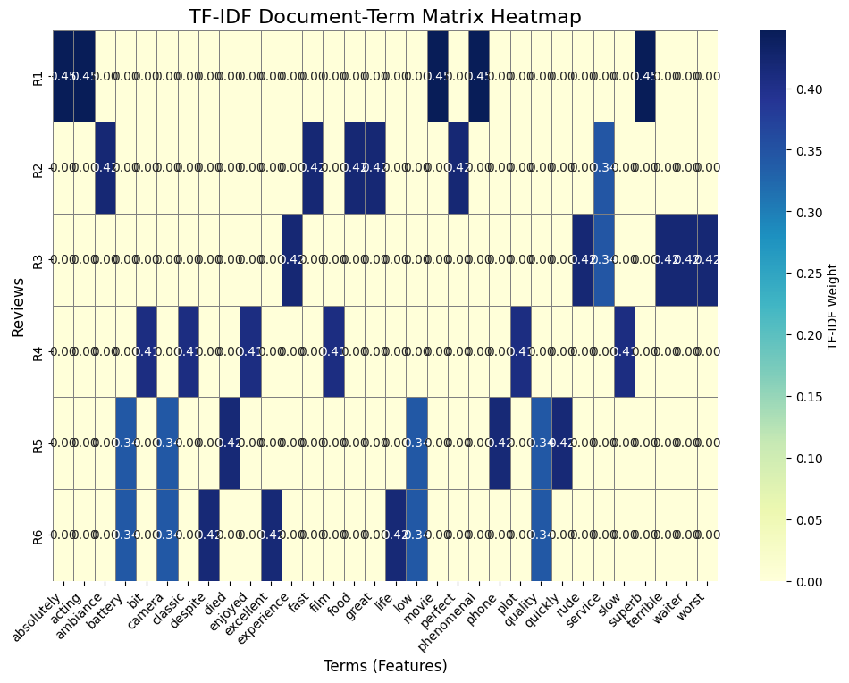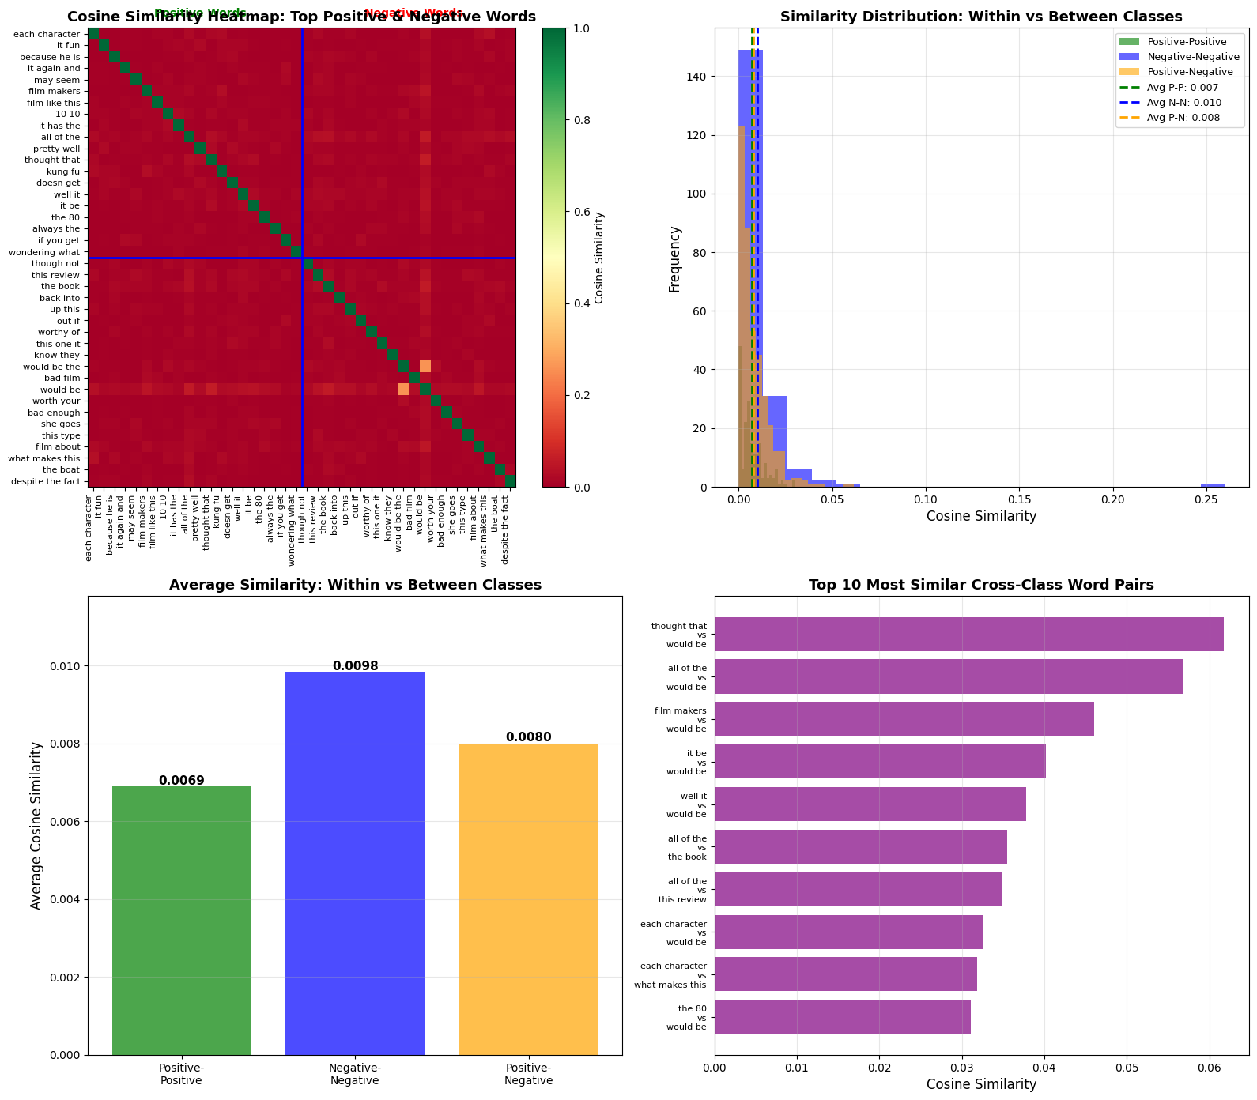

Plots illustrating n-gram performance, vocabulary size, confusion matrix, and model metrics.

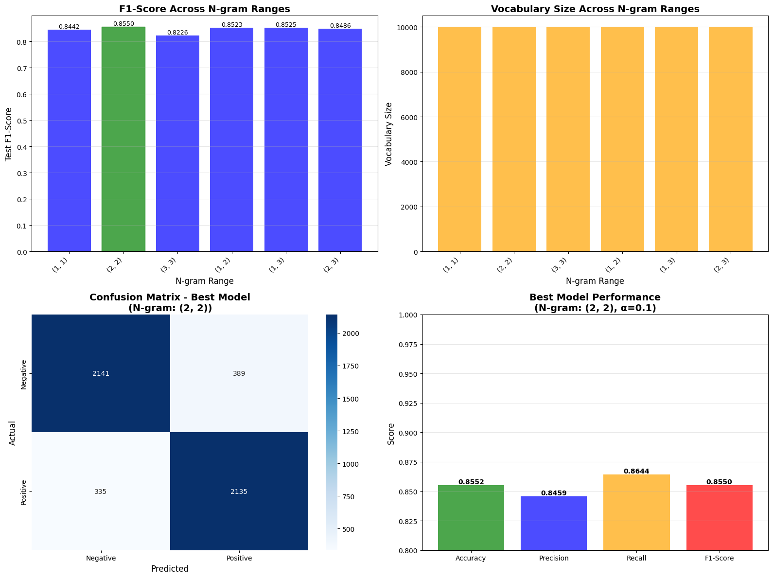
Graphs detailing error distribution, confidence levels in errors, and review length analysis for misclassified samples.
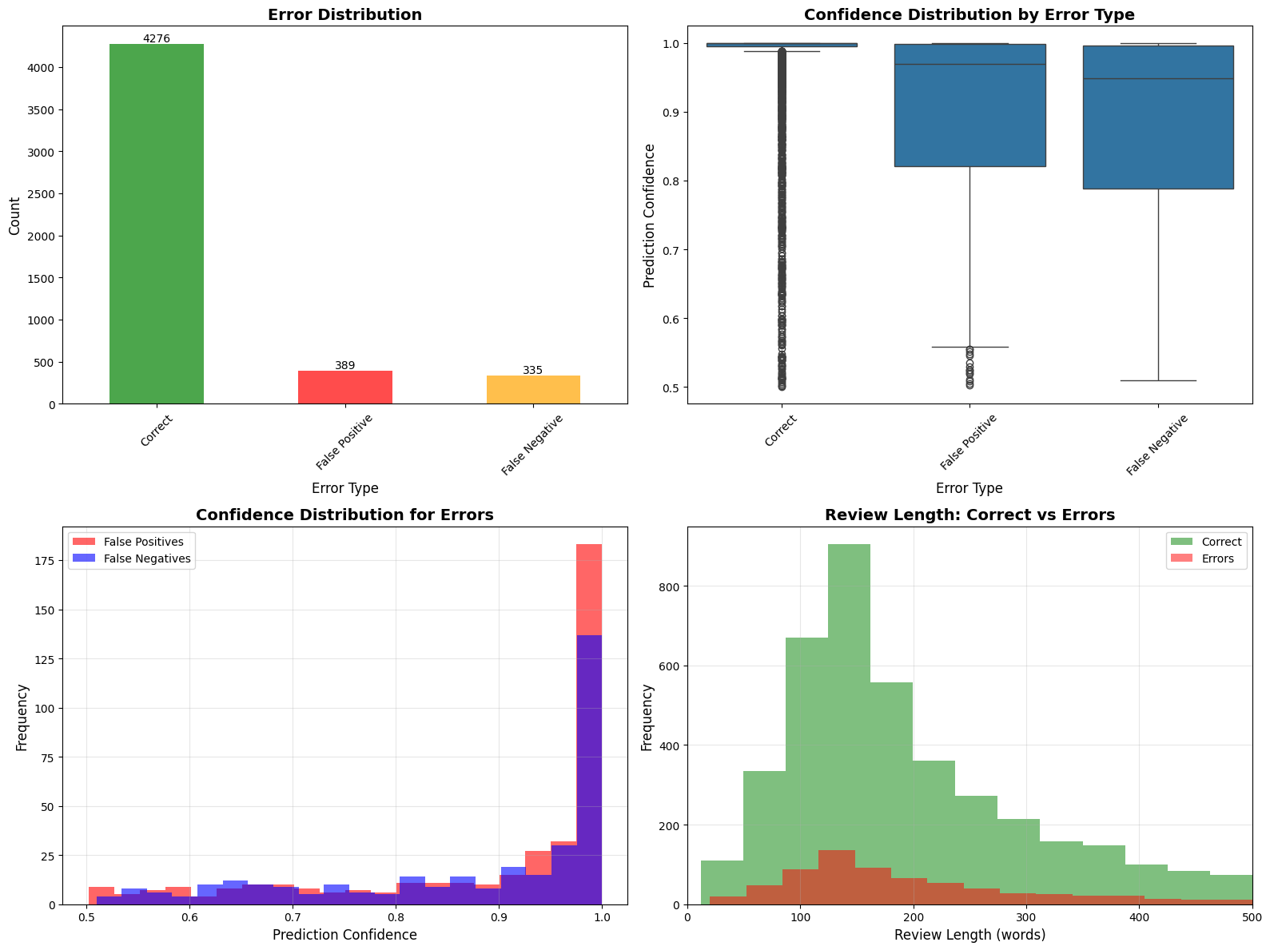

Histograms and bar charts comparing within-class and between-class cosine similarities of top predictive features.


Limitations and future works
Limitations
- Sentiment Blindness of Traditional VSMs: As observed, `CountVectorizer` (and TF-IDF) primarily captures word frequency and co-occurrence, struggling with semantic nuances like sarcasm, irony, or negations without more sophisticated techniques.
- Lack of Contextual Understanding: The MNB model, based on bag-of-words features, has limited ability to understand the deeper semantic meaning or sequential dependencies in sentences.
Future Work
1. Advanced Vectorization: Exploration could be done on word embeddings (e.g., Word2Vec, GloVe, FastText) or contextual embeddings (e.g., BERT, RoBERTa) to capture deeper semantic relationships and context beyond n-grams.
2. Deep Learning Models: Implementing neural network architectures such as Recurrent Neural Networks (RNNs), Long Short-Term Memory (LSTMs), or Transformer-based models, which are generally more adept at handling sequential data and complex language patterns, potentially improving performance on nuanced reviews.
3. Sarcasm Detection: Development of specific strategies or integration of models explicitly designed to detect sarcasm and irony, which were identified as major sources of misclassification.

